**DESIGN PATTERNS AND PRINCIPLES.**

**Exercise 1: Implementing the Singleton Pattern**

**Scenario:**

You need to ensure that a logging utility class in your application has only one instance throughout the application lifecycle to ensure consistent logging.

**Steps:**

1. **Create a New Java Project:**
   * Create a new Java project named **SingletonPatternExample**.
2. **Define a Singleton Class:**
   * Create a class named Logger that has a private static instance of itself.
   * Ensure the constructor of Logger is private.
   * Provide a public static method to get the instance of the Logger class.
3. **Implement the Singleton Pattern:**
   * Write code to ensure that the Logger class follows the Singleton design pattern.
4. **Test the Singleton Implementation:**
   * Create a test class to verify that only one instance of Logger is created and used across the application.

**SOLUTION**

Logger.java

public class Logger {  
 private static Logger *instance*;  
 private Logger() {  
 System.*out*.println("Logger Created!");  
 }  
 public static Logger getInstance() {  
 if (*instance* == null) {  
 *instance* = new Logger();  
 }  
 return *instance*;  
 }  
 public void log(String message) {  
 System.*out*.println("LOG: " + message);  
 }  
}

main.java

public class main {  
 public static void main(String[] args) {  
 Logger logger1 = Logger.*getInstance*();  
 logger1.log("This is the first message.");  
 Logger logger2 = Logger.*getInstance*();  
 logger2.log("This is the second message.");  
 if (logger1 == logger2) {  
 System.*out*.println("Same Logger used. Singleton is working!");  
 } else {  
 System.*out*.println("Different Loggers. Singleton is not working.");  
 }  
 }  
}

OUTPUT:

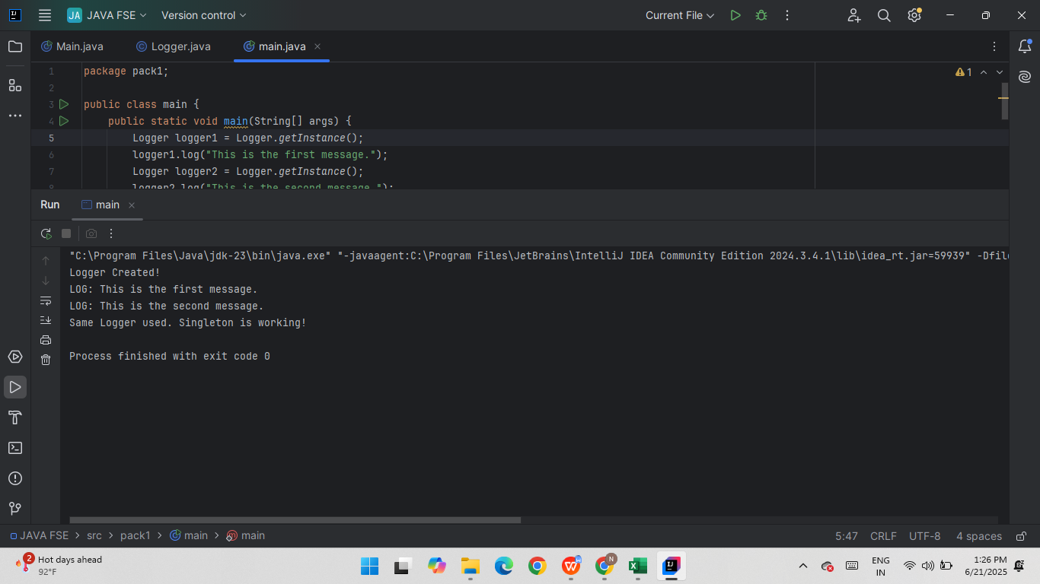

**Exercise 2: Implementing the Factory Method Pattern**

**Scenario:**

You are developing a document management system that needs to create different types of documents (e.g., Word, PDF, Excel). Use the Factory Method Pattern to achieve this.

**Steps:**

1. **Create a New Java Project:**
   * Create a new Java project named **FactoryMethodPatternExample**.
2. **Define Document Classes:**
   * Create interfaces or abstract classes for different document types such as **WordDocument**, **PdfDocument**, and **ExcelDocument**.
3. **Create Concrete Document Classes:**
   * Implement concrete classes for each document type that implements or extends the above interfaces or abstract classes.
4. **Implement the Factory Method:**
   * Create an abstract class **DocumentFactory** with a method **createDocument()**.
   * Create concrete factory classes for each document type that extends DocumentFactory and implements the **createDocument()** method.
5. **Test the Factory Method Implementation:**
   * Create a test class to demonstrate the creation of different document types using the factory method.

**SOLUTION**

document.java

public interface document {  
 void open();  
}

WordDocument.java

public class WordDocument implements document {  
 public void open() {  
 System.*out*.println("Opening a Word document.");  
 }  
}

PdfDocument.java

public class PdfDocument implements document {  
 public void open() {  
 System.*out*.println("Opening a PDF document.");  
 }  
}

ExcelDocument.java

public class ExcelDocument implements document {  
 public void open() {  
 System.*out*.println("Opening an Excel document.");  
 }  
}

DocumentFactory.java

public abstract class DocumentFactory {  
 public abstract document createDocument();  
}

WordDocumentFactory.java

public class WordDocumentFactory extends DocumentFactory {  
 public document createDocument() {  
 return new WordDocument();  
 }  
}

PdfDocumentFactory.java

public class PdfDocumentFactory extends DocumentFactory {  
 public document createDocument() {  
 return new PdfDocument();  
 }  
}

ExcelDocumentFactory.java

public class ExcelDocumentFactory extends DocumentFactory {  
 public document createDocument() {  
 return new ExcelDocument();  
 }  
}

Main.java

public class Main {  
 public static void main(String[] args) {  
 DocumentFactory wordFactory = new WordDocumentFactory();  
 document word = wordFactory.createDocument();  
 word.open();  
  
 DocumentFactory pdfFactory = new PdfDocumentFactory();  
 document pdf = pdfFactory.createDocument();  
 pdf.open();  
  
 DocumentFactory excelFactory = new ExcelDocumentFactory();  
 document excel = excelFactory.createDocument();  
 excel.open();  
 }  
}

**OUTPUT**

